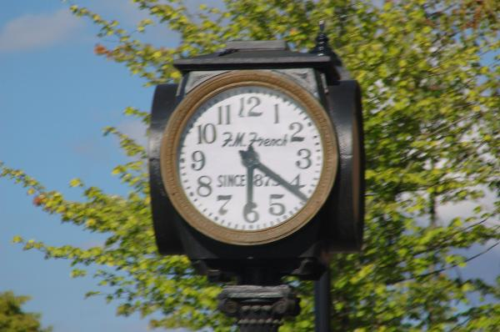
This clock stands on the corner of 1st and Ellsworth (Albany Oregon), where everyone coming into town from the north passes by. The reference on the face of the clock to F.M. French relates to the French's Jewelry store that was on that corner for over a century. The date on the clock face is 1875--and the clock is running a little fast on the date of the waymark submission.
There is still a jewelry store on this corner, but it is no longer French's. However, the old clock remains, to continue marking time.
Status: Working
Display: Free Standing
Year built:
